Sal f
Golden Valley High School
Wm. S. Hart Union High School District
“Home of the Grizzlies”
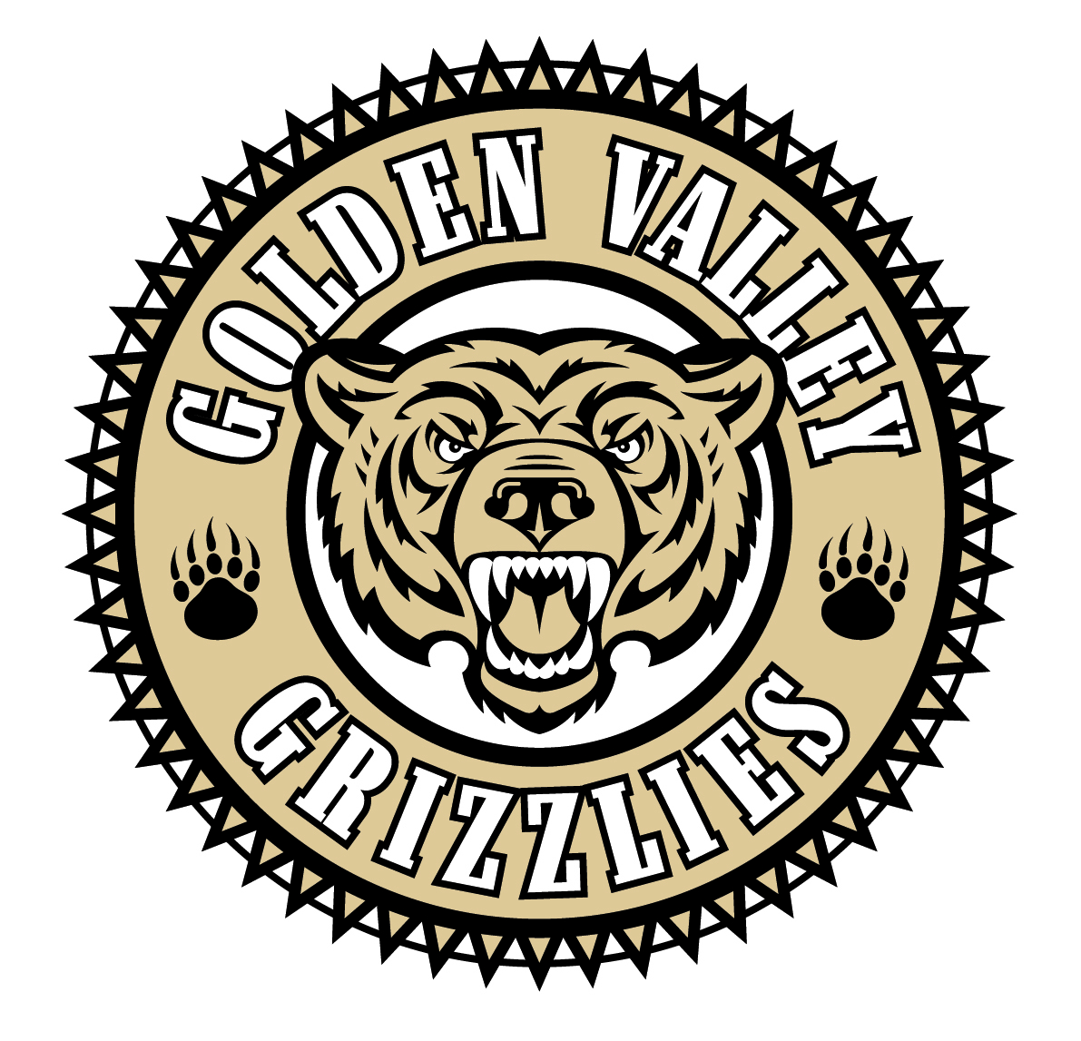
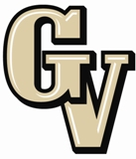

Parent Advisory Council (PAC) Meeting
October 28, 2013
6:30 PM

AGENDA

- PAC Meeting Welcome Sal Frias

- Secretary’s Report ACTION Jennifer Ryan

- Treasurer’s Report ACTION Emily Curtis

- President’s Report Sue Alterman

- District Advisory Council (DAC) Report Monica Camacho

- Parent Communications Council (PCC) Report Cherise Moore

- Introduction of Asst. Superintendent, Mike Vierra

- School Safety Deputy, Mike Perry

- Science Department Update Tom Gavin

- AP Results Completion Sal Frias

- Common Core Update Sal Frias

Announcements: -November 1st is a Non Student Teacher Voluntary Work Day
-CAHSEE for 11th and 12th graders on Nov. 5th - 8th
-November 8th is a two hour late start
-Veteran’s Day is Monday, November 11th
-11th graders participate in Connect to Success on November 14th
-2nd quarter progress reporting period ends on November 15th
-African American College Planning Conference on Nov. 16th
-ASB Food Fest #2 on Wednesday, November 20th
-Fall Play, “Almost Maine” is November 20th - 22nd
-Fundraisers for boys basketball, band, GVTV and baseball are going on.

Next Meeting: November 25, 2013

The mission of GVHS is to provide a quality education to a diverse student population, develop each student’s maximum potential, and prepare students for success in the global community.

